**SKILLS TEST 4 *(Torque and the Motor Effect)* NAME_____________________**

*(22 Marks, 22 Minutes)*

1. A uniform beam 5.00 m long has a mass of 35 kg. It is lying horizontal with 2.0 m of its length protruding over the edge of a building. A 75.0 kg stunt man is on the end that is not supported. What mass must be placed on the other end so that the man does not fall.

*(4 Marks)*

**4 (WATP 2011 Qu 5)**

*Diagram is not drawn to scale.*

An iron ball of mass 220 kg is suspended from the end of a rigid steel girder.

Steel wire

Pivot point

1.60 m

50º

Girder mass 180 kg

Rigid upright

Iron ball

mass 220 kg

65º

The girder has a mass of 180 kg and a length of 2.40 m.

The girder is pivoted to a rigid upright.

A steel wire is attached 1.60 m along the girder. It holds it in equilibrium with angles between components as shown in the diagram.

1. Identify all four forces acting on the girder by drawing them on the diagram.

*(1 Mark)*

1. Calculate the magnitude of the tension in the steel wire.

*(4 Marks)*

3. Determine the direction of current in each of the following situations (add arrows).

a.Motor – side AB turns into the page b. C.

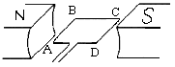

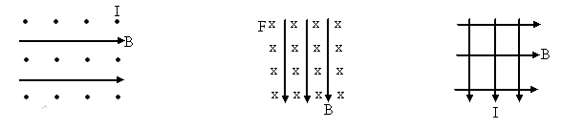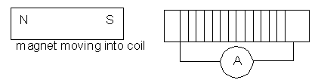

N

*(3 Marks)*

4a) A wire carries a current of 300 mA. What is the magnetic field strength 30 mm from the wire?

*(2 Marks)*

b) Another parallel wire 30 mm from the first wire carries a current of 900 mA in the opposite direction. Will these wires attract or repel each other and what is the magnitude of the force involved?

*(3 Marks)*

5. **(WATP 2009)** The following diagram represents one of 100 loops in an electric motor coil. The arrows on the coil represent the direction of the conventional current flow in the coil.

0.20 m



(a) What is the direction of the force on AB? Indicate the direction on the diagram.

*(1 Mark)*

(b) If the magnetic field has strength of 0.55 T and AB is 0.40 m in length and 2.0 A flows in the circuit then what is the maximum torque experience by the motor?

*(4 Marks)*

ANSWERS

3 0.5 2

1 ✓

F (35)(9.8) (75)(9.8)

Σ acwm = Σcwm

3F + (0.5)(35)(9.8) = 2(75)(9.8) ✓

3m(9.8) + (0.5)(35)(9.8) = 2(75)(9.8)

m = 44.2 kg ✓✓

2 a. Identifies all 4 forces ✓

Steel wire

Pivot point

1.60 m

50º

Girder mass 180 kg

Rigid upright

Iron ball

mass 220 kg

65º

Action force from weight

= 220 × 9.8

Weight

= 180 × 9.8

Reaction from pivot

Tension

b. Take moments about pivot ΣM = 0 M = r.F.sin θ

Σacwm = Σcwm

1.60×T×sin 50 = (1.20×180×9.8×sin 65) + (2.4×220×9.8×sin 65)

correct lever arms ✓ recognises sin θ for all torques ✓

T = 6608.071 / (1.60 × sin 50) = 5391.39 ✓

T = 5.39 × 103 N ✓ (along the wire)